Database Design — ERD & Data Dictionary Notes
COE 454 — Week 3 Deliverable 2 (ERD, min 4 entities — this design has 20) Owner: Backend Lead · DDL in schema.sql

Design rules applied everywhere
- Audit fields: every table carries created_at, updated_at; master data adds created_by/updated_by (FK → users).
- Soft delete: master data (products, suppliers, customers) uses deleted_at; people use is_active. Transactional records (sales, movements) are immutable — corrected by compensating records, never edited (BR-04).
- Stock is a ledger. stock_movements is append-only; a batch’s quantity is the sum of its movements. batches.qty_on_hand is a denormalized running total maintained in the same transaction (guarded by SELECT … FOR UPDATE).
- All quantities are integers in the product’s base unit (tablets, ml, pieces). Packs/strips/cartons convert through product_units at the edge, so stock math never sees fractions.
- Money is NUMERIC(12,2) GHS. Never floats.
- Idempotent sync: sales.client_sale_id (UUID, unique) makes offline replays safe (ADR-006).

Entity-Relationship Diagram
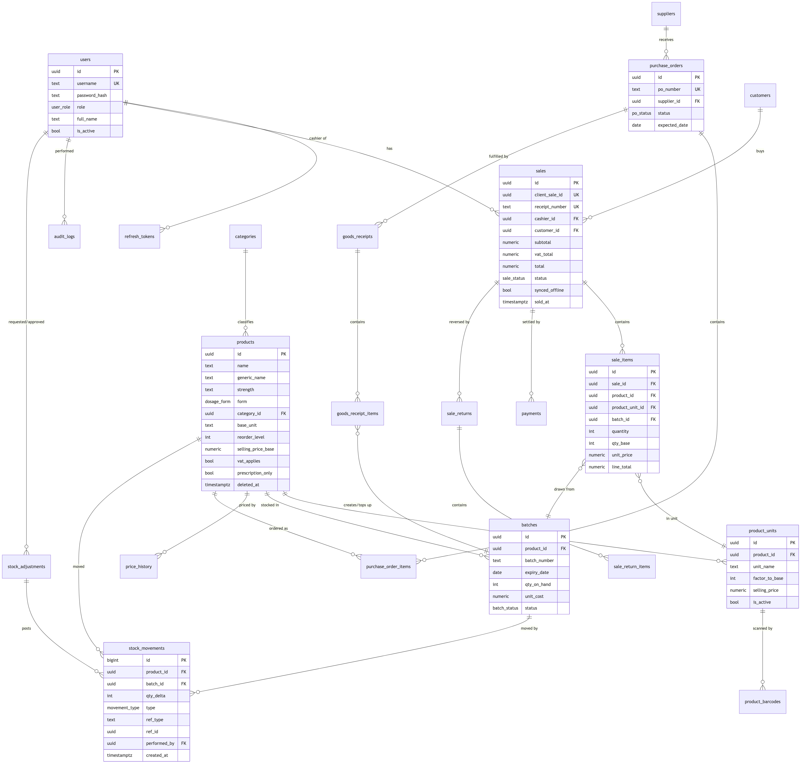
Figure 1
(Attribute lists abbreviated for readability; schema.sql is authoritative and includes payments, customers, suppliers, goods_receipts, stock_adjustments, sale_returns, audit_logs, settings, price_history, refresh_tokens.)

Normalization
The schema is in third normal form (3NF):
- 1NF: no repeating groups — multiple barcodes per product live in product_barcodes rows, not a comma-separated column; multiple pack sizes live in product_units.
- 2NF: every non-key attribute depends on the whole key — e.g., unit_price sits on sale_items (depends on the sale line), not on sales.
- 3NF: no transitive dependencies — supplier contact details live only in suppliers, never copied onto purchase orders; category name only in categories.
Deliberate, documented denormalizations (performance/immutability, each justified):
Field | Why
batches.qty_on_hand | Hot-path read for POS and dashboards; recomputable from stock_movements (invariant checked by a nightly job).
sale_items.unit_price, line_total; sales.total | Point-in-time snapshot: receipts must not change when prices change later (BR-03/BR-04).
stock_movements.qty_delta sign convention | Positive = stock in, negative = stock out; avoids joins to interpret the ledger.

Keys, constraints & integrity highlights
Concern | Mechanism
Primary keys | UUIDv7 app-generated (sortable, offline-safe); stock_movements uses BIGINT IDENTITY (append-only ledger)
No oversell (online) | Batch rows locked FOR UPDATE inside the sale transaction; qty_on_hand may go negative only via the offline-sync path, which flags an exception (ADR-006)
Expired stock unsellable | batches.status derived by nightly job + CHECK (expiry_date > sold-at) enforced in service layer; report view v_expired_stock
Valid money/quantities | CHECK (quantity > 0) on sale/PO/receipt lines; CHECK (factor_to_base >= 1); CHECK (total >= 0)
Duplicate scans | product_barcodes.barcode globally unique
Idempotent offline sync | sales.client_sale_id unique
Referential integrity | FKs everywhere with ON DELETE RESTRICT (history is protected); soft delete instead of row deletion

Indexes (beyond PKs/UKs)
Index | Serves
GIN (name gin_trgm_ops), GIN (generic_name gin_trgm_ops) on products | <300 ms fuzzy search over 10k SKUs (NFR-01)
batches (product_id, expiry_date) WHERE status = 'ACTIVE' | FEFO pick + expiry dashboards
stock_movements (product_id, created_at DESC) | Product movement history
stock_movements (ref_type, ref_id) | Trace a sale/receipt to its ledger entries
sales (sold_at DESC), sales (cashier_id, sold_at) | Z-reports, cashier reports
sale_items (product_id, created_at) | Top-sellers, product sales history
audit_logs (entity, entity_id, created_at DESC) | Entity audit trail

Reporting views
v_stock_on_hand (per product: base-unit qty, unit breakdown, valuation at cost), v_low_stock, v_expiring_batches (30/60/90-day windows), v_expired_stock, v_daily_sales (Z-report source), v_shrinkage (adjustments by reason). Defined in schema.sql §7 — the reporting module reads only these views.

